How to backup EC2 instances using AWS Backup

AWS Backup?

AWS Backup is a fully managed backup service that makes it easy to centralize and automate data backup across AWS services in the cloud and on-premises.

Currently, AWS Backup allows you to backup the following AWS services:

1. Amazon EBS

2. Amazon EC2

3. Amazon RDS

4. Amazon DynamoDB

5. Amazon EFS

6. AWS Storage Gateway

7. Amazon FSx

Step 1: Open the AWS Console and search for AWS Backup, Click On Create Backup plan.

Step 2: Select Build a new plan and give the Backup plan name

Mention the Backup rule name and mention the backup frequency like Daily, Hourly, Every 12 hours, Weekly, Monthly or Use Custom Cron Expression and

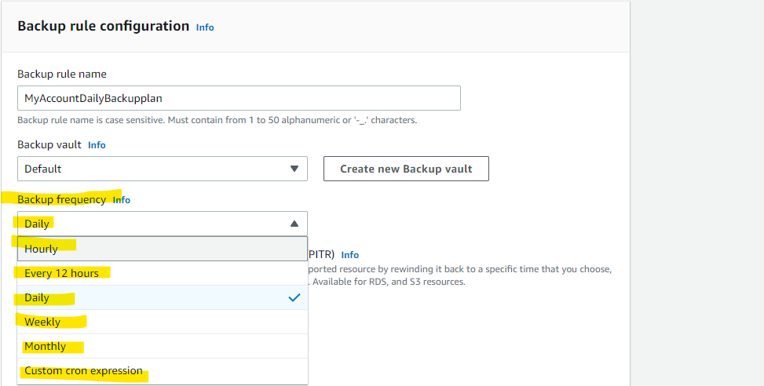

Select the Customized backup window and mention the retention period (If we want to mention retention of 30 days, After AMI creation of 1 day, we can give 30 days). Now the Backup window start time starts at 06:30 PM UTC I,e Triggers at 12:00 AM IST. We will set up a retention period ad Backup window start time based on the client’s requirements.

(Mention AMI will create within 1 hour and completed within 2 or 3 hours) and mention for which region we need to create AMI from the servers.

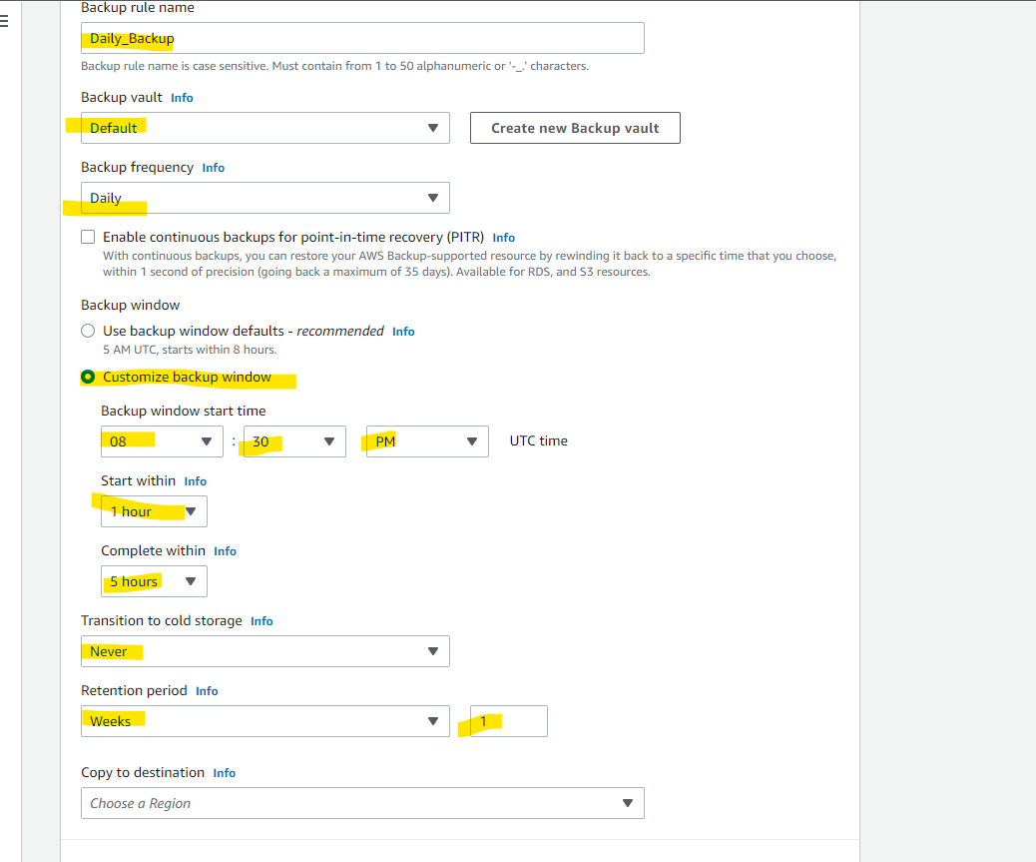

If any third-party applications are running inside the ec2 server, we can enable Windows VSS (Based on Client requirements), From the above sheet do not select copy to destination to the region. If we select copy to destination, it will again copy from the created backup.

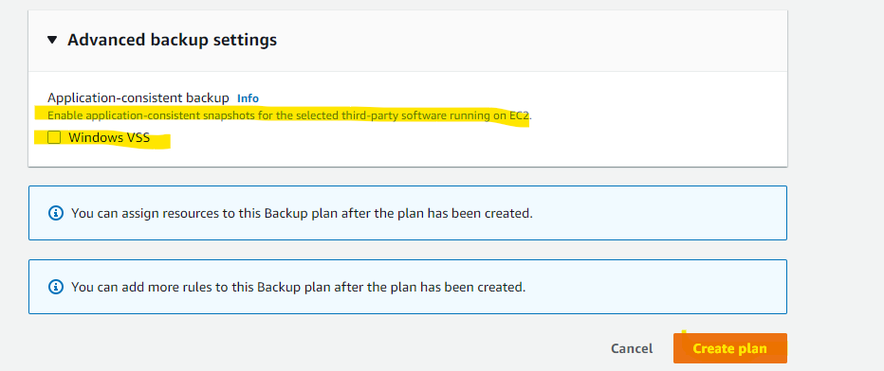

Now, Click on Create Backup Plan.

Step 3: Assign the Resource Assignments to the backup plan (Instances)

Step 4:

Select specific resource types (EC2, S3, EBS, EFS, FSX, etc…….)

In EC2 Select all the instances in select specific resource types. For Ex: If the customer does not need a backup for some of the servers we can select Exclude specific Resources that servers.

From The above screenshot if we will select all resources. It includes ((Amazon EBS, Amazon EC2, Amazon RDS, Amazon DynamoDB, Amazon EFS, AWS Storage Gateway, and Amazon FSx).

If we want a Particular Service then we can select below.

From the above, we have Excluded the backup for (I-0aa02bb07efe85eed For Test-Server).

Total Description:

The AMI Backup will start daily at 12:00AM IST with a daily retention period.

The AMI will start the backup within an hour and it will be complete within 2hours.

Finally OUTPUT:

Check the AMI in the console.